Le Quy Don primary school

Name:.......................................

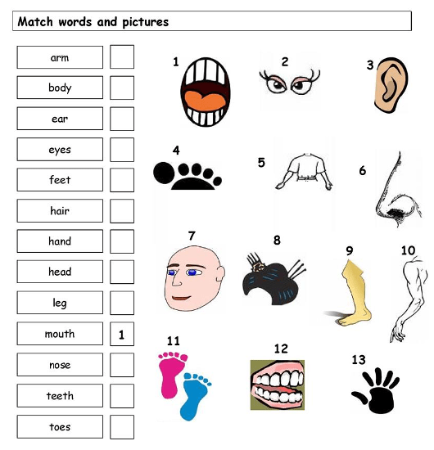Class:........................................

**REVIEW UNIT 5 (1)**